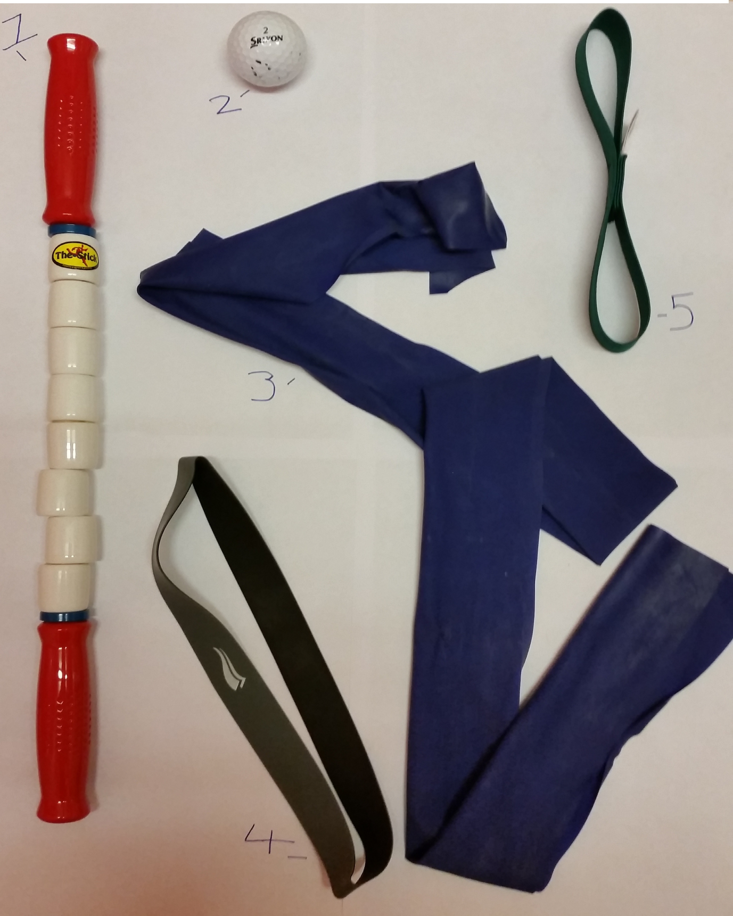
- 1 The Stick – To segmentally compress and stretch muscles.
- Prevent and prodict muscle injuries
- Dramatically improve strength, flexibility and endurance
- Rapidly prepare muscles for physical activity
- Disperse the effects of lactic acid following activity
- Accelerate muscle recovery
2 The golf ball – To relieve tight muscle and prevent inflammation or prevent fasciitis.
Step 1: Take off your shoes and socks and place a golf ball under one foot. Starting from the front, work the ball back toward your heel. (Freezing the golf ball ahead of time can help relieve inflammation.)
Step 2: As you roll the ball, apply pressure where needed. “If you find a spot that is particularly tender, hold it there for at least 15 to 20 seconds,” Warren says. “Move on, but revisit it again one more time.”
3 Yoga band – For strengthening ankle and improving flexibility and mobility
4 Resistance loop band – For strengthening hips glutes helping prevent itb issues
MSD band anckleciser – For strengthening ankle and tendons. Full excercises on www.msd-band.com

